Project Design Phase-II
Technology Stack (Architecture & Stack)
Date | 24 September 2026
Team ID | SWTID-2026-7356
Project Name | AI StudyBuddy
Maximum Marks | 4 Marks

Technical Architecture:
The deliverable includes the architecture diagram below and the information in Table-1 and Table-2. AI StudyBuddy is an AI-powered educational backend built with Node.js, Express.js, MongoDB and Google Gemini 2.5 Flash. The diagram shows the layers from the client to the database and the AI service.

Technical Architecture Diagram – AI StudyBuddy
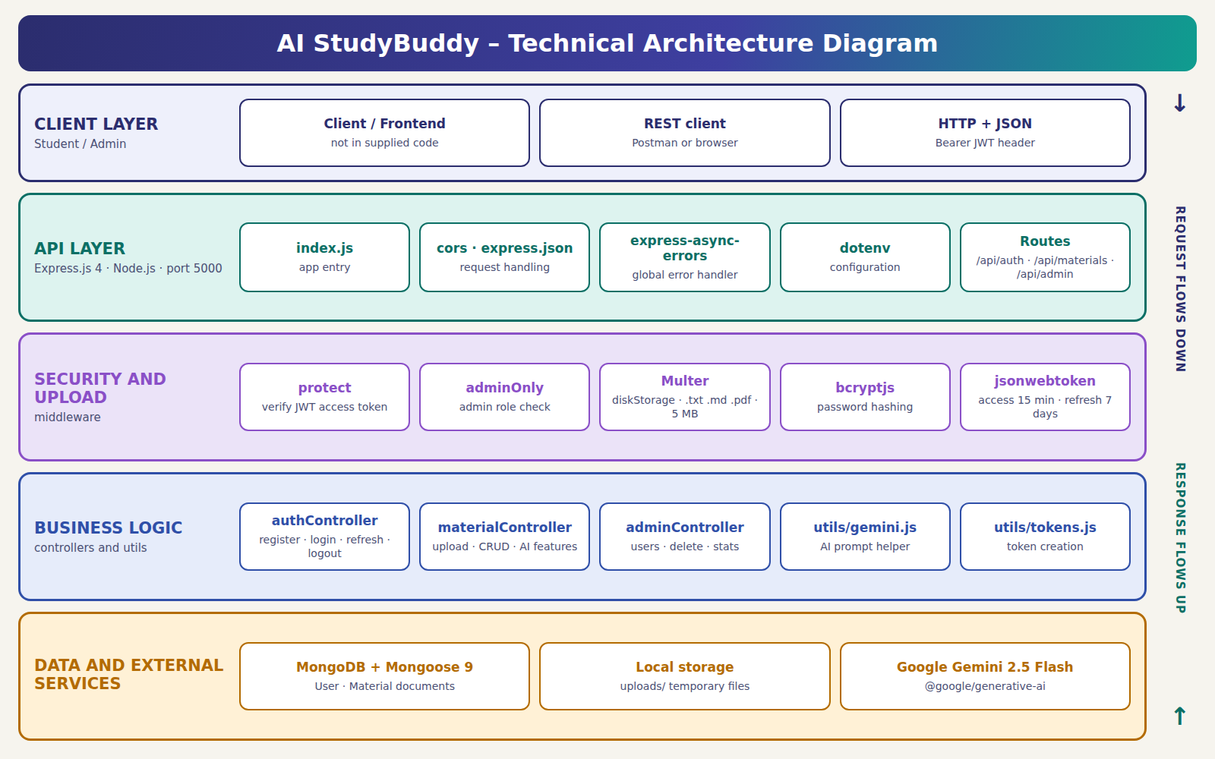

Table-1 : Components & Technologies:
S.No | Component | Description | Technology
1 | User Interface | The supplied project is a backend REST API. A client or frontend talks to it using HTTP and JSON. No frontend code is included in the source. | REST API endpoints, JSON, HTTP, CORS
2 | Application Logic-1 | Authentication and authorization: registration, login, token refresh, logout, JWT verification through the Bearer header, and student / admin role control. | Node.js, Express.js, jsonwebtoken, bcryptjs
3 | Application Logic-2 | Study-material management: upload, view, list and delete materials, with file-type validation and temporary local storage. | Node.js, Express.js, Multer, fs, path
4 | Application Logic-3 | AI-powered study functions: summary, flashcards, multiple-choice quiz and personalised study plan generation. | @google/generative-ai, Gemini 2.5 Flash
5 | Database | Stores User and Material documents, including user details, uploaded text, summaries, flashcards, quizzes and study plans. | MongoDB, Mongoose ODM
6 | Cloud Database | No cloud database is specified in the project. The application connects through a configurable MONGO_URI. | MongoDB; location depends on MONGO_URI
7 | File Storage | Uploaded .txt, .md and .pdf files are saved temporarily in the local uploads/ folder, read by the server and deleted after reading. PDF text extraction is a planned improvement. | Local filesystem, Multer diskStorage
8 | External API-1 | Generates AI responses for summaries, flashcards, quizzes and study plans. | Google Gemini API
9 | External API-2 | No second external API is used in the source code. | Not applicable
10 | Machine Learning Model | A generative AI model turns the uploaded study text into summaries, flashcards, quizzes and study plans. | Google Gemini 2.5 Flash
11 | Infrastructure (Server / Cloud) | Runs as a Node.js server on a configurable port (default 5000). No cloud deployment, load balancer or container setup is included. | Node.js runtime, Express server, local deployment

Table-2 : Application Characteristics:
S.No | Component | Description | Technology
1 | Open-Source Frameworks | Open-source Node.js packages handle the API server, database access, authentication, file upload, CORS, configuration and error handling. | Express, Mongoose, Multer, bcryptjs, jsonwebtoken, cors, dotenv, express-async-errors
2 | Security Implementations | Passwords are hashed before saving. JWT access (15 min) and refresh (7 days) tokens are used, protected routes verify the access token, admin routes need the admin role, and uploads are limited by extension and 5 MB size. | bcryptjs, JWT, role-based access control, Multer filter and limit, CORS
3 | Scalable Architecture | A modular Express API with separate routes, controllers, middleware, models and utilities. It is not built as microservices. | Node.js, Express modular design, MongoDB, Mongoose
4 | Availability | No load balancing, failover or high-availability setup is included. Availability depends on the server and MongoDB deployment used. | Express server, MongoDB, deployment configuration
5 | Performance | Requests and database calls run asynchronously. Uploads are limited to 5 MB, temporary files are deleted after reading, and user email has a unique index. | async/await, MongoDB, Mongoose, Multer limits, unique email index

